**Long Term Viability of**

**‘The Showcase with IMAX’**

The Global Cinema Market, as it is currently constructed, is a rapidly decaying dinosaur that will soon be extinct. Market forces, such as the changing movie audience and politics, are rapidly shaping the future of the cinema experience.

The Showcase with IMAX is built from the ground up to be fiscally and structurally sound to thrive in these prevailing winds of change.

*Parameters of the Discussion:*

* The Showcase with IMAX is scheduled to open in the fourth quarter of 2016.
* For the sake of this confab,
* Short Term will be defined as the first three (3) year span of a ten (10) year bank loan.
* Long Term will be defined as the subsequent seven (7) years of the aforementioned.

There are two areas that must be considered to understand the long term viability of ‘The Showcase with IMAX’.

* Global Market Trends

1. Direction of the Market
2. Expansion of the Traditional Concession Stand

***Global Market Trends***

1. Direction of the Market

Understanding the future of cinema in the Bahamas requires a look at the present political/ policy changes that have happened or are about to transpire.

1. 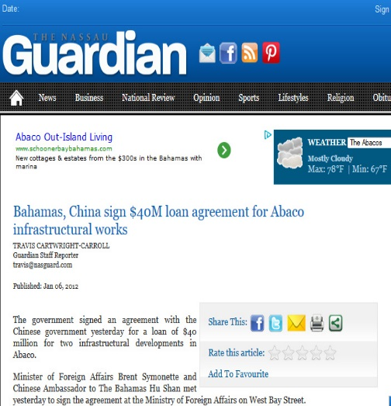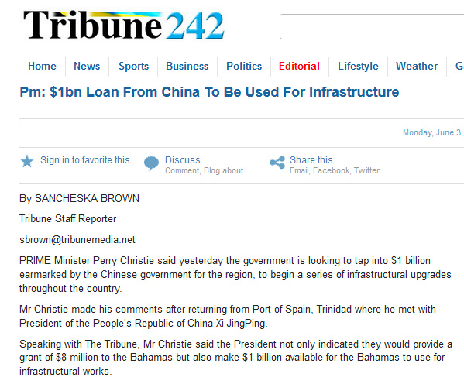Growing relationship with China and the Bahamas
2. 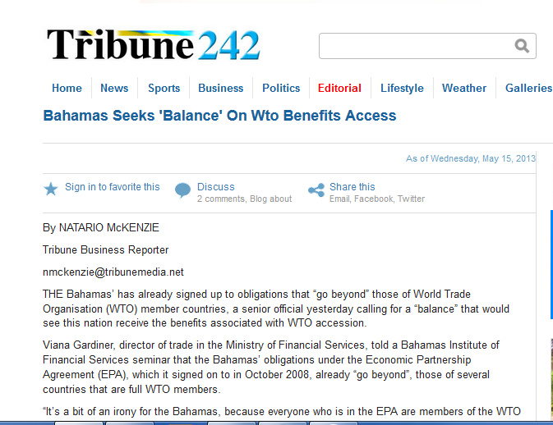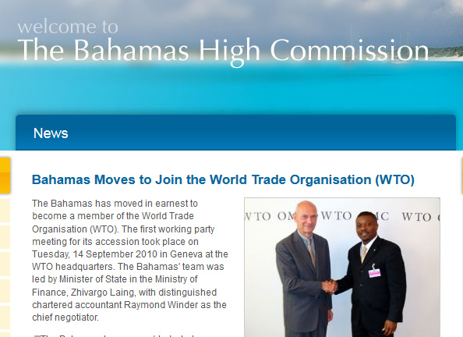 The Bahamas application for entry into the World Trade Organization (WTO)

These two points are very relevant for similar reasons. Both of these situations will open Bahamian borders, thereby severely limiting the protectionist policies of the government.

Why is this relevant?

**China is now the most important player in the cinema industry.**

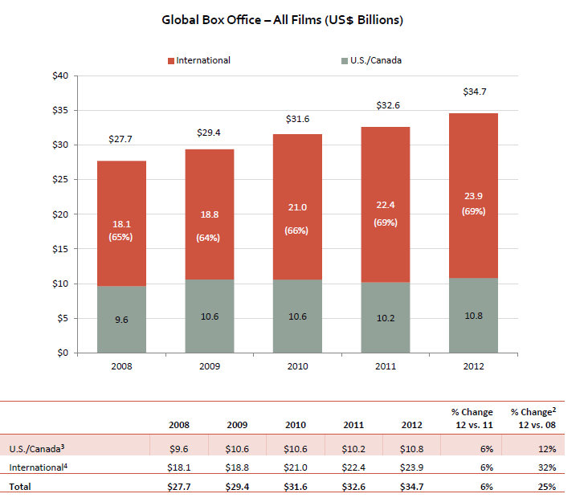The landscape of the movie industry has changed. The Global Box office (BO) is growing faster than the US BO.

By 2018 China’s BO. will become the largest in the world surpassing the US’BO.

With this switch comes the ability to be the determining factor of movie content in Hollywood. If that gigantic shift was not enough, the Chinese have instituted two (2) changes.

1. 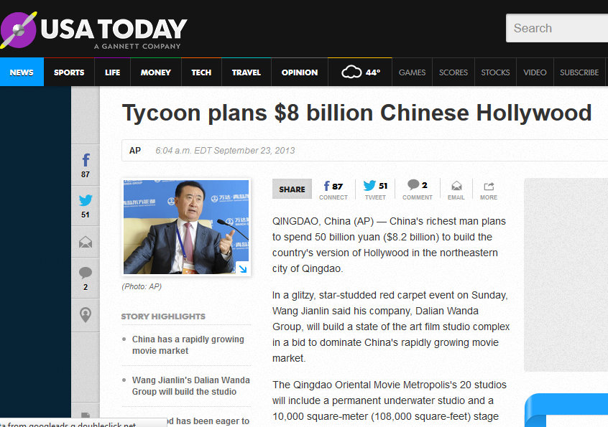Welcome to the New ‘Hollywood’ of the Pacific

Wang Jianlin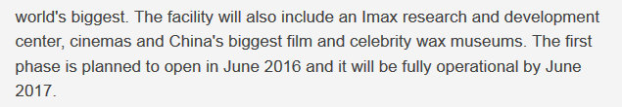, China’s richest man is building the world’s biggest movie studio to replace Hollywood and meet his country’s growing demand. What does he put as the centerpiece of the $8 billion development? An IMAX R&D center.

This new content from China will need theaters to play in, hence step two (2)

1. Two Asian companies are in a race to become the #1 movie chain in the World:

Wanda Group of China and CJ CGV of South Korea

They are doing this by expanding into new territories and buying competitors or opening their own franchises.

Example:

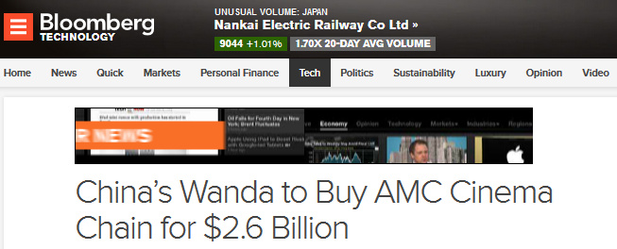Wang Jianlin and the Wanda Group bought American Movie Cinemas (AMC) to become the largest movie chain in the world.

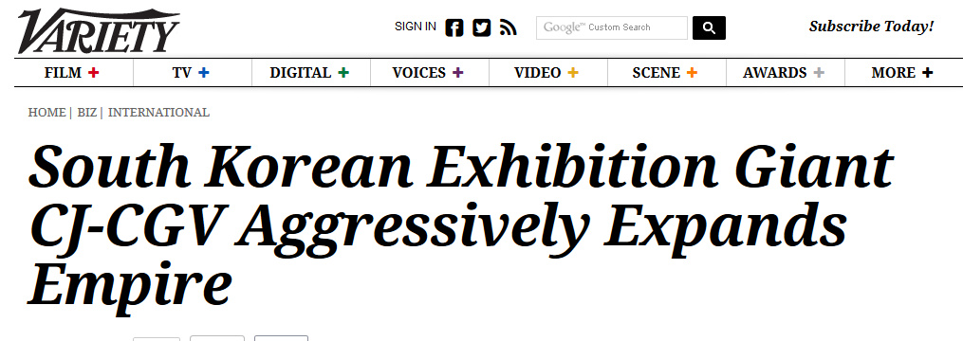CJ CGV has taken the opposite approach, buying smaller cinema chains.

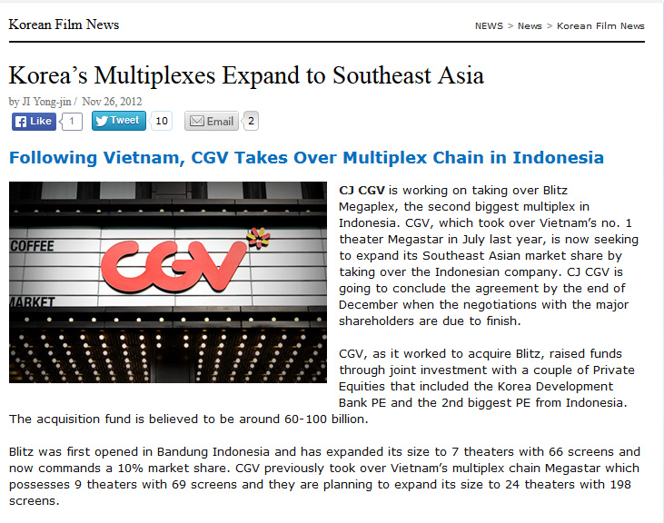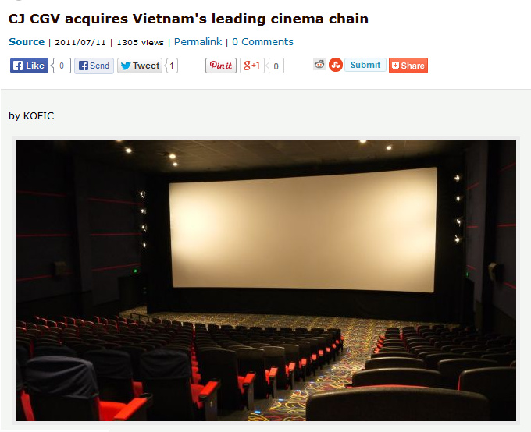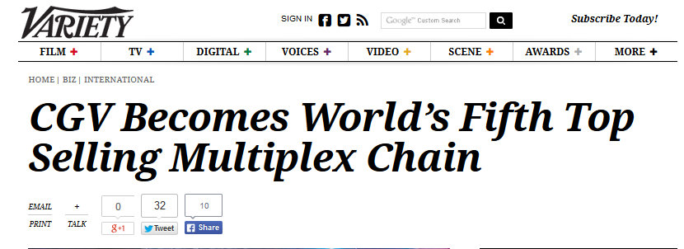By the end of 2013 CJ CGV was one fifth of the way to their goal.

What is the relevance of this to the Showcase with IMAX and the Bahamas?

The ever increasing Asian influence in the Bahamas combined with the WTO’s free trade requirement have opened the market for entry to Wanda and CJ CGV.

***Why is the Showcase with IMAX averse to their market penetrance?***

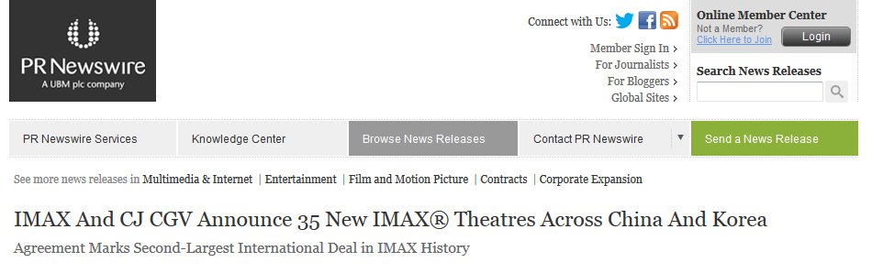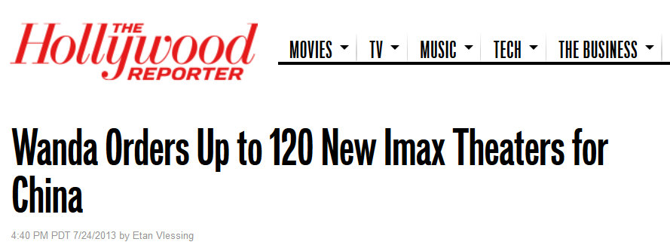Understanding the tools of choice these corporations use to enter markets then differentiate themselves from existing theaters is key.

Both CJ CGV and Wanda use IMAX as their preferred weapon for market penetration. CJ CGV has more potential to expand because of their proprietary theater system

Fortunately for the Showcase with IMAX, the same holds **10 year exclusive contracts** for both IMAX and 4DX technologies in the Bahamas. A contractual relationship has already been developed with CJ CGV the largest developer of Asian/ K-POP content.

1. Expansion of the Traditional Concession Stand

How concessions will be handled is a differentiation factor in the Bahamian market as it has been in the past.

**History Lesson**

One of the dynamics that allowed Galleria Cinemas to eclipse RND Cinemas in the early 2000s was concessions.

When movie patrons arrived at RND cinemas in the late 90s, they had a choice. Either they could fight through the cramped lobby to get concessions on a long line or join the line to their theater for a good seat. Many customers chose the latter.

When Galleria Cinemas entered the market in 1999 with their seemingly endless lobby and expansive food choices, Bahamians were smitten. Hence besides the revenue from movie ticket sales, Galleria had a fiscal advantage with its concession profit margin.

**Déjà vu**

As the Showcase with IMAX enters the market, concessions again become a point of differentiation. How? This first requires a look at the global trends for long term viability to be realized.

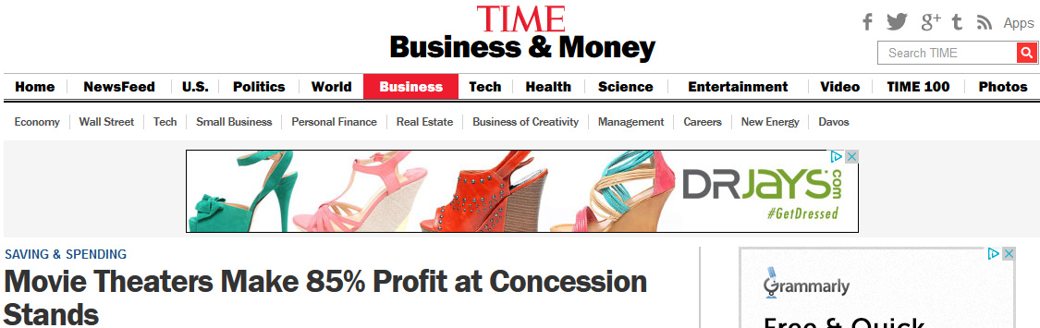**Global Movement**

Concessions are the Holy Grail of theater chains. Ironically, popcorn and other theater staples weren’t allowed in cinemas until after the Great Depression. Theater owners did not like the mess these food items created.

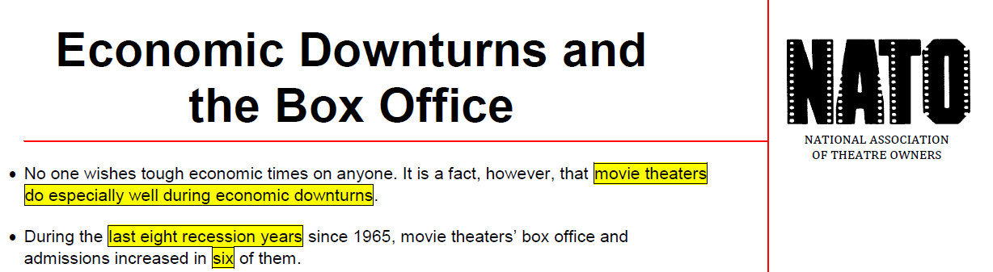For theater owners over the last decade concession sales have grown faster than ticket sales. This global phenomenon has been attributed to the worldwide recession. During recessionary periods more people go to cinemas.

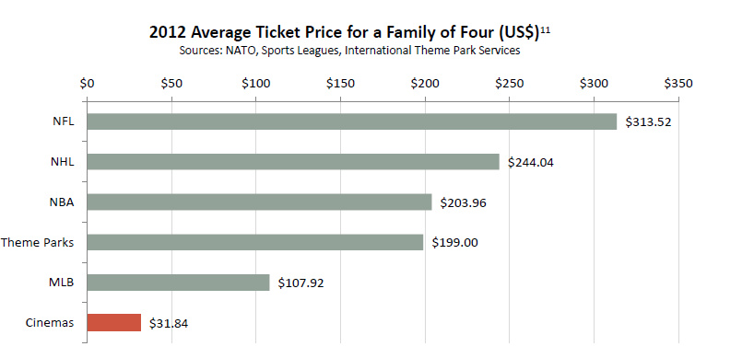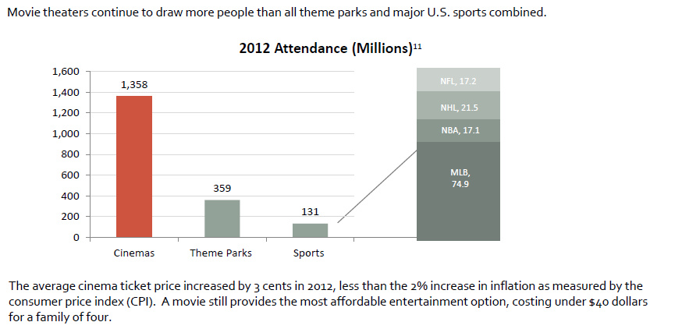Why? It’s the cheapest form of entertainment that allows one to escape from everyday woes.

In the Bahamas, the issues are the opposite. The choice are even less for family entertainment. Hence movies are the de facto choice to escape everyday reality.

Globally, people are combining entertainment and the desire to eat out while at the movies.

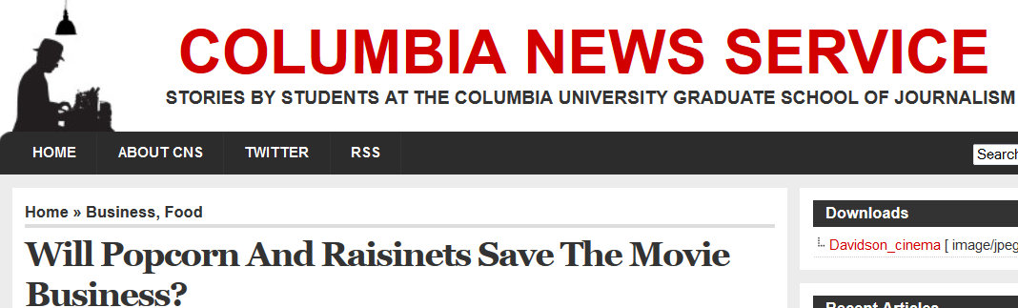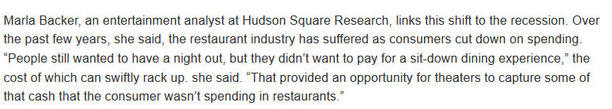Researchers at Columbia University and Hudson Square Research studied this phenomenon.

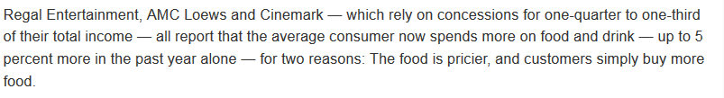The Big Three theater chains AMC, Regal and Cinemark are seeing the difference:

Two of the Big Three have expanded their offering to accommodate this shift in consumer spending.

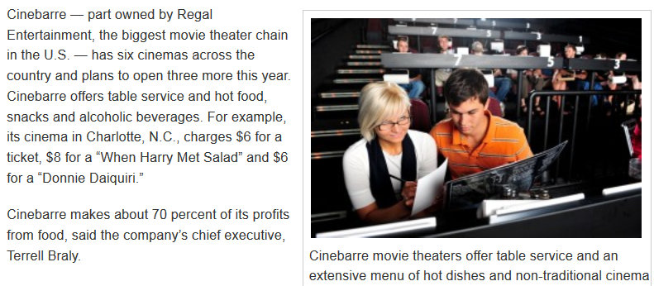AMC‘s Screen and Fork and Regal’s Cinebarre lounge/dine- in theater concepts have been very successful.

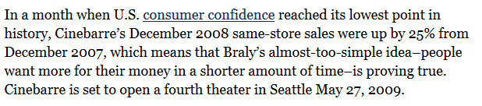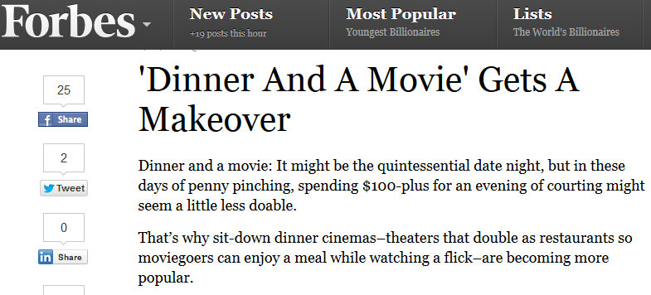Forbes Magazine commented on the thriving industry for theaters:

What is the draw to these lounges in Cinemas? AMC, the world’s leading movie understands the draw to these lounges; Premium formats in the facility like IMAX.

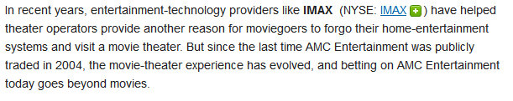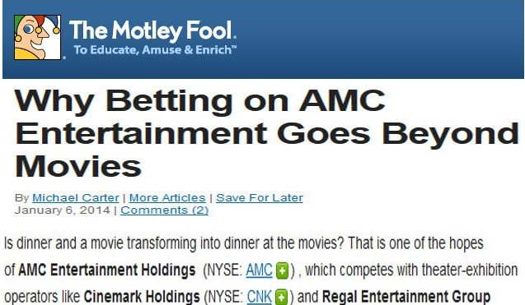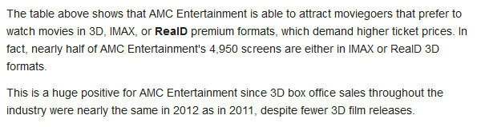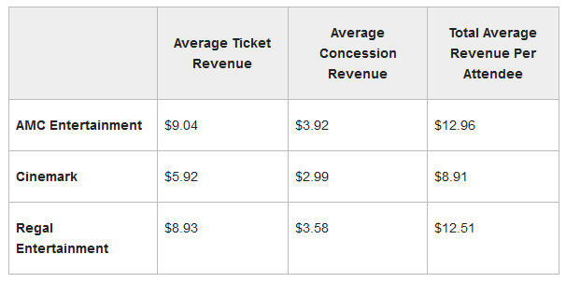With nearly half of is auditorium in IMAX or 3D, AMC has used this premium to maximize its concessions. They are able to charge more compared to its competitors with less IMAX screen.

**Question:**

***But isn’t all food the same whether it come from the lounge in a theater or a restaurant?***

The answer is a resounding NO in the eyes of consumers.

Researchers have found that consumers look at food served in a restaurant as the main attraction versus food served at a movie theater where the movie is the main attraction.

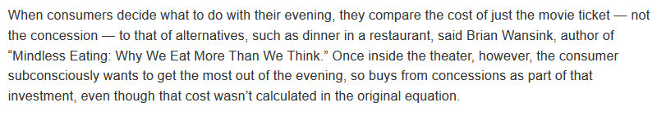Dr. Brian Wansink author of, ‘Mindless Eating: Why we eat more than we think’ describes this phenomenon

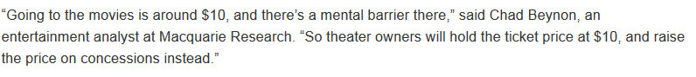. Entertainment Industry Analyst descripted the buying habit of Theater patrons at concession stands and in cinema lounges as being in a vacation mind set.

This premise may be new to the western hemisphere but lounges and VIP theaters have been an entertainment fixture for more than a decade in Asian and European cinemas.

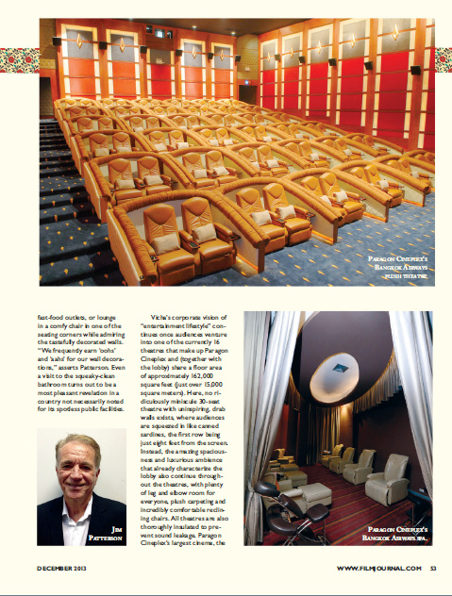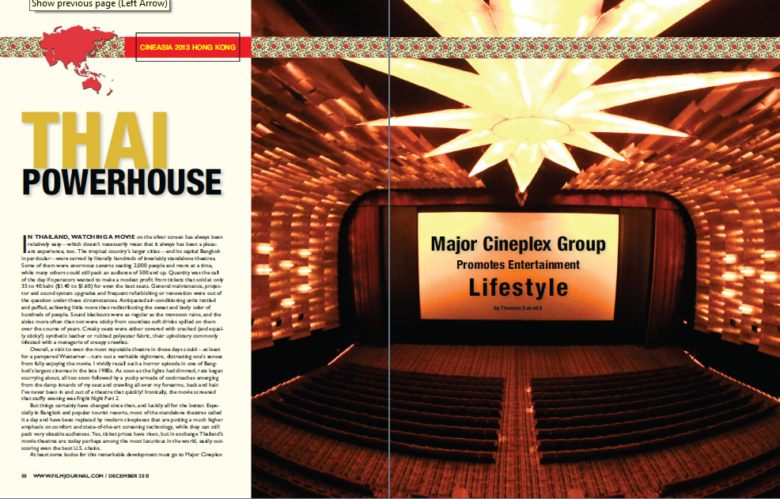In fact the lead consultant for this project Jim Patterson was just honored by industry magazine, Film Industry Journal, Dec 2013, for his role in structuring the VIP experience.

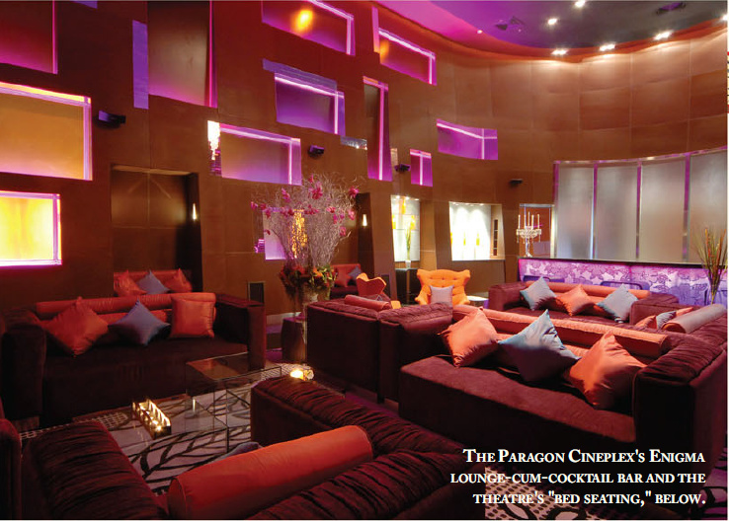Jim’s facility was recognized as one of the best theaters in the world because of its extensive offerings to movie goers.

Whether it’s the lounges or the innovative technology, Paragon has been driving the movie going experience for over a decade.

With Jim’s guidance on the project, this is what The Showcase will bring to the Bahamian people. Whether it’s the lounges upstairs or exotic gourmet popcorn down stairs, The Showcase with IMAX will have differentiated concessions from Galleria Cinemas.